Need Fishing Equipment?
No need to sit on the shore and wish you were fishing…
I know what it’s like to not be able to pack everything…if you need fishing gear I can help!

RENT fishing rods and tackle from local guide:
Wade Watson Voyageurs Adventures
St. Croix Rods, TFO, Bayport Custom Rods, or Berkley Rods
Northland Tackle, Rapala, and more…

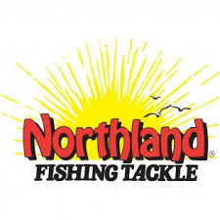
Top of the line equipment to use for the day, 3 days, or the week…

Daily Rate: ROD/REEL (St. Croix or similar with Piscifun Carbon reel)
*all rods are lined and equipped like I would use on a guided fishing trip!
$30/Day, $70 for 3 days, ask about longer rentals
Small/Med Tackle Box: $20 ($10 each additional day)

SPECIAL: 2 Rods & Tackle Box- $60 (each additional day $30)


Call/Text- Wade Watson 651-303-1252
www.kabfishing.com

